Energy Meter Software

The application begins with a secure Login Page, which ensures that only authorized users can access the system. Users are required to enter their username and password to sign in and proceed to the main dashboard. The interface also provides additional options such as “Create Account” for new users and “Forgot Password?” for account recovery, enhancing usability and security. The design of the login screen is minimal and user-friendly, with a dark background and a central input form that keeps the user’s focus on authentication. This access control mechanism safeguards sensitive machine performance data and ensures that only authenticated personnel can monitor or manage the industrial machines.

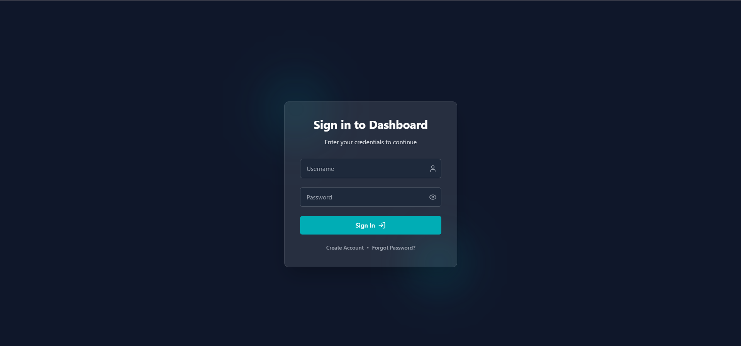

Machines Dashboard (Main Dashboard Overview)
The main dashboard provides a centralized view of all connected industrial machines, making it easy for operators to monitor and manage machine availability in real time. Each machine is represented in a dedicated card that displays its name, operational status, location, and creation details. For example, machines like Mazak H400 and AceMicromatics LT2 LM500 are shown as Active, along with their respective installation locations such as SMDDC-Line2. The dashboard also provides quick indicators such as machine ID and online/offline status, ensuring that supervisors can instantly identify machine health and connectivity. Additionally, a quick summary box at the top-right highlights the total number of machines currently available, offering a high-level overview of the workshop’s operational readiness. From this screen, users can drill down into detailed energy monitoring of individual machines by selecting the eye icon provided on each machine card.

Main Dashboard
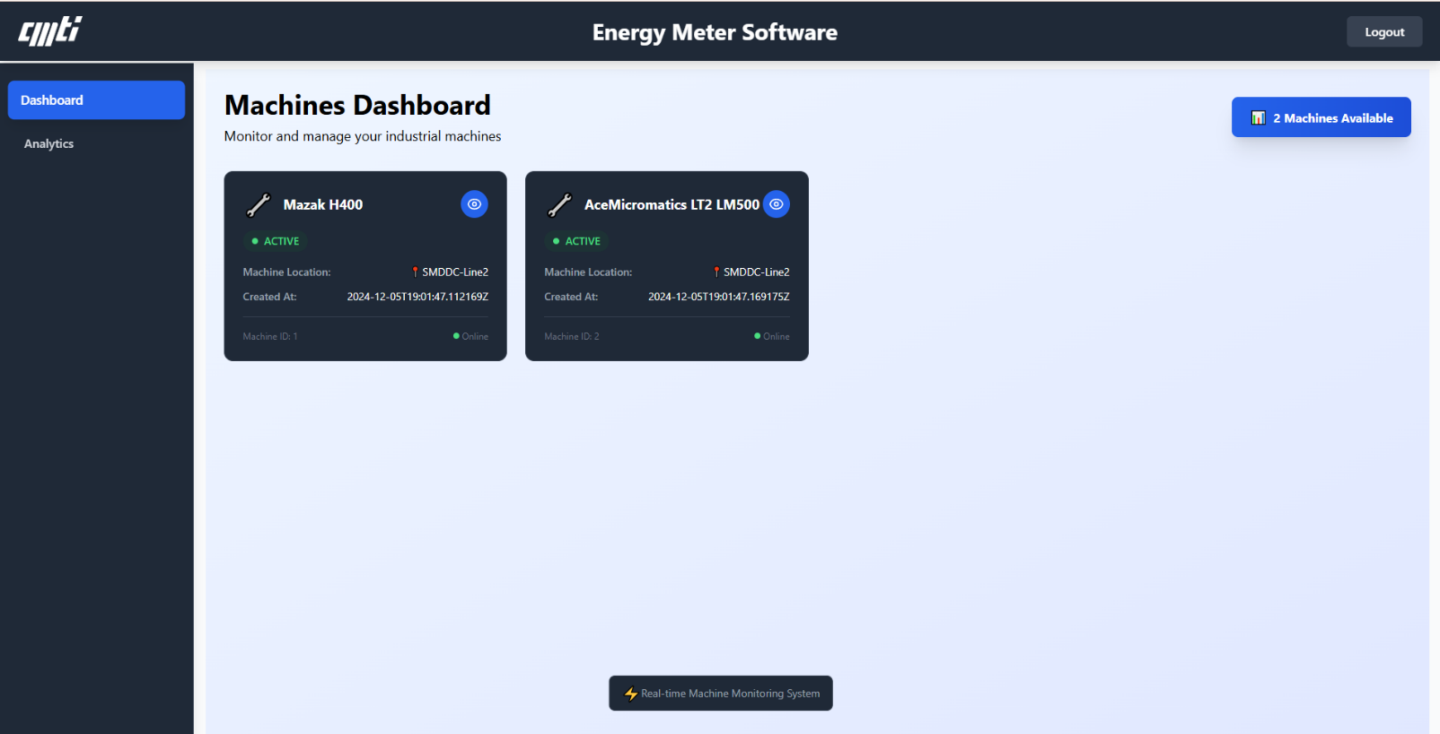

Machine-Specific Energy Dashboard (Detailed View)
When a user clicks on the eye icon from the main dashboard, the system opens a detailed energy monitoring dashboard for the selected machine. This page provides real-time insights into multiple performance parameters of the machine. The energy section displays the total energy consumption in kilowatt-hours (kWh), which in the case of Mazak H400 is shown as 9717.59 kWh, giving a clear understanding of cumulative usage. The power section shows the instantaneous power in watts (W), here approximately 674 W, helping operators gauge the current load on the machine. Similarly, the current section provides the average current in amperes (A), with per-phase details for R, Y, and B phases, making it easier to detect unbalanced loads. Voltage readings are displayed with average values and per-phase details, ensuring precise monitoring of electrical health.
Additional machine details are also included in the dashboard, such as machine name, location, operational status, and last updated timestamp, which aids in historical reference and traceability. The dashboard further highlights advanced electrical parameters like power factor per phase, frequency stability (around 50.09 Hz), and line-to-line voltages (VRY, VYB, VBR phases). These details are crucial for monitoring machine efficiency and preventing power quality issues. Finally, the interface includes a live trend graph under “Parameter vs Time,” where the last 10 data points of selected parameters such as total watts are plotted. This feature allows operators to visually analyze variations in machine performance over time, supporting predictive maintenance and energy optimization.

Particular Machine Detailed Viewer Page
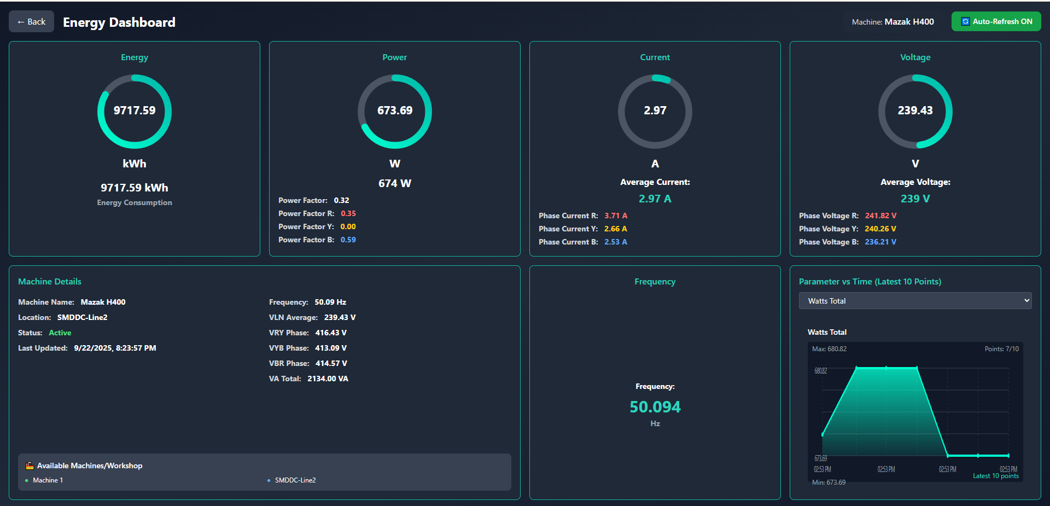

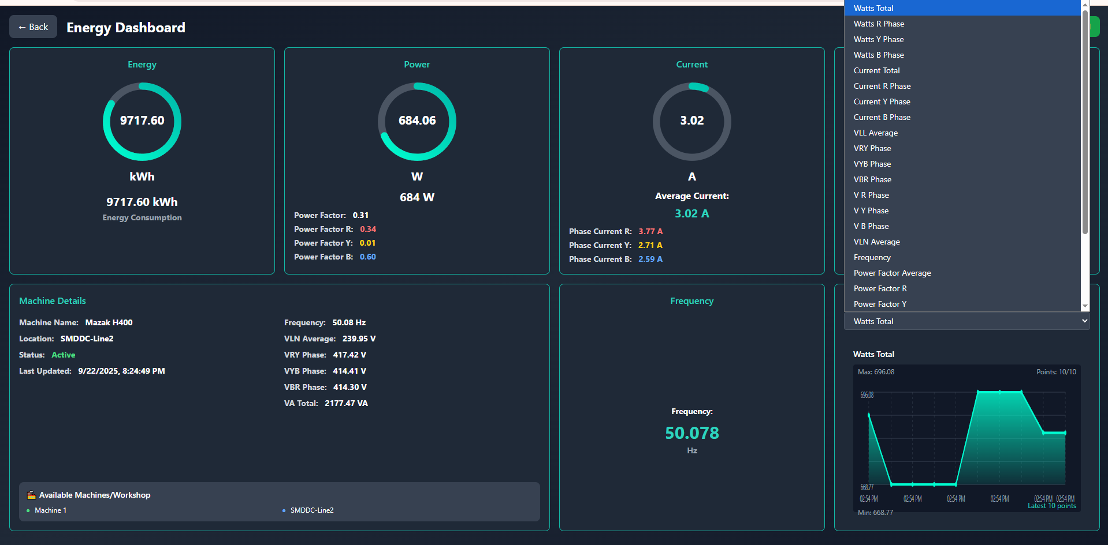

Analytics Dashboard
Machine Analytics Dashboard of an Energy Meter Software application, which is designed to monitor and analyze machine performance data in detail. At the top, the section titled Machine Analytics highlights its purpose of monitoring performance with advanced smoothing options. Below this, users can configure analysis settings by selecting the machine (in this case, Mazak H400 – SMDDC-Line2), the parameter to analyze (Power Factor Average), and a date range (from 21-09-2025 to 22-09-2025). There are also advanced data smoothing options, including the choice of smoothing method (currently set to No Smoothing), window size adjustment, and an outlier threshold slider.
The lower section displays a time-series graph of the Power Factor Average for the selected machine within the given date range. The chart visualizes fluctuations in the power factor across time intervals, with data points. The graph shows variations in the power factor values, ranging approximately between 0.2889 and 0.3673, indicating operational performance patterns and possible irregularities. This visualization helps in identifying trends, anomalies, and efficiency metrics, making it a useful tool for engineers and operators to analyze machine health, detect anomalies, and optimize performance.

Analytics Dashboard
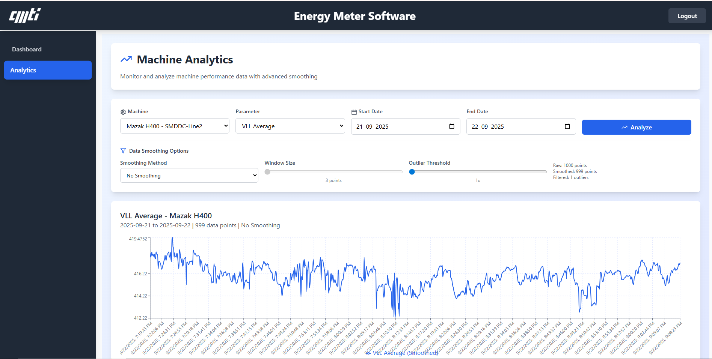
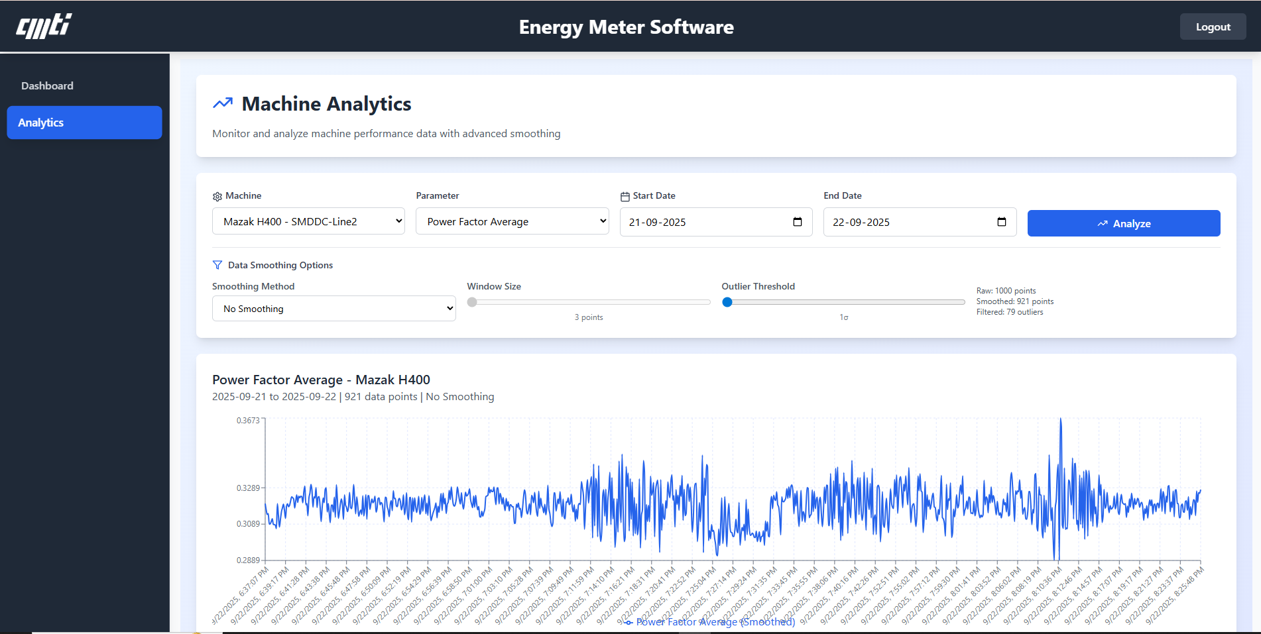
Frontend Components Table

